

**STEM Lesson n°1**

**« Discover Robotics by Building Pedro!**

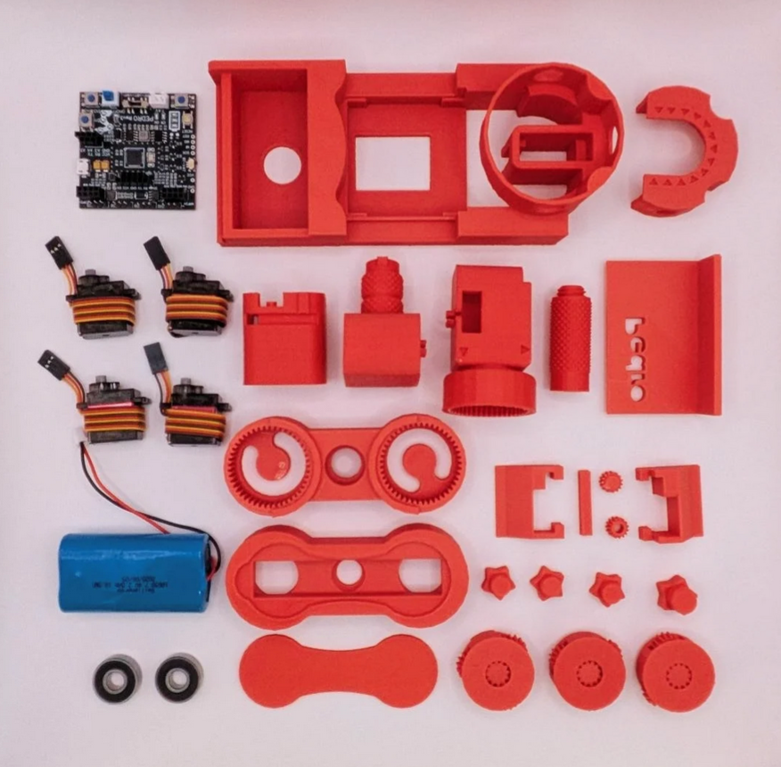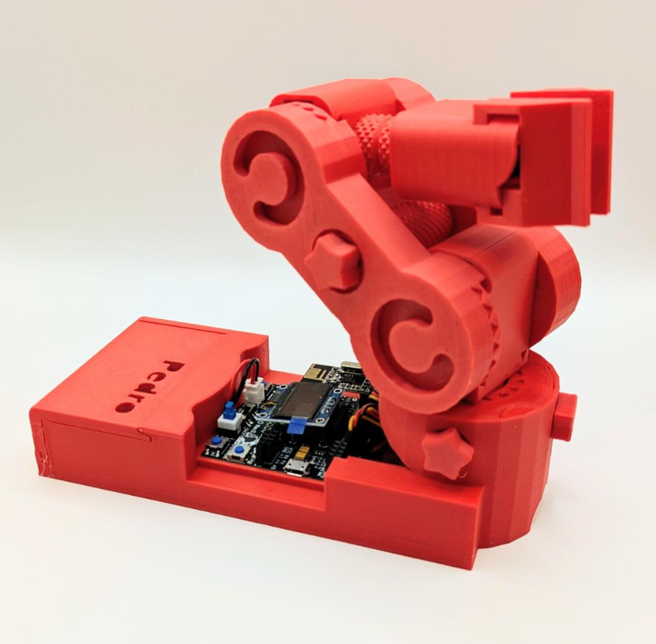

**v1.0.1**

***PDF Tricks  
(To make sure the PDF file that opens in your browser shows the most up-to-date version,   
add a version query to the URL, like this:  
https://almtzr.github.io/PedroSTEM/stem_lessons//myfile.pdf?****v=2****)***

## ****🎯 Learning Objective****

This lesson introduces students to **P.E.D.R.O the Programmable Educational Robot**, fully 3D-printed, open-source robot designed to make robotics learning fun and hands-on. By the end of this session, students will:

* Understand the basics of ****robotics and embedded systems****
* Learn ****how 3D printing works**** and how robots are designed
* ****Assemble**** and ****control**** their own Pedro robot
* ****Upload code**** to Pedro using the Arduino IDE
* Identify and explain the ****main components**** of a robot

## ****👨‍🏫 Instructor Notes****

* Recommended age: **12 years and older**
* **Ideal for STEM clubs, classroom workshops, or science projects**
* **Students should have basic computer literacy**
* Duration: ~**2 hours**

## ****🧰 Required Materials****

| Item | Quantity | Description |
| --- | --- | --- |
| Pedro Robot Full Kit | 10 units | One robot by student |
| Computer (Windows, Linux, or OS X) | 1 or 2 units | With Arduino IDE installed |

## ****🧩 Final Activity****

At the end of the workshop:

* Students complete a **30-question quiz** to review key concepts.
* Teachers can discuss real-world applications of robotics and 3D printing.

**Table of Contents**

🎯 Learning Objective 2

👨‍🏫 Instructor Notes 2

🧰 Required Materials 2

🧩 Final Activity 2

1. Materials Check 4

2. What Is 3D Printing? 5

3. Design 6

3.1 The Pedro Anatomy 6

3.2 Planetary Gear System 7

3.3 What is a planetary gear system in robotics? 7

3.4 Why use a planetary system on Pedro? 7

4. The Pedro Board 8

4.1 Main Features 8

4.2 STEM Insight 8

4.3 Identify Each Element of the Pedro Board: 9

5. Installing and Uploading Pedro Firmware 12

6. Assembling 13

Step 1: The Base 13

Step 2: The Gripper 14

Step 3: The Arm 15

7. Quiz (30 Questions) 16

## **1. **Materials Check****

**Make sure you have all the parts before starting the assembly.   
Check all the parts by putting an ✅ next to each part of Pedro robot.**

✅ All Pedro 3D printed parts

✅ Pedro Rev3 Electronic Board

✅ 2 ball bearings **8x22x7 mm**

✅ 4 continuous rotation (**360**°) servomotors

✅ 7.4V DC battery



💡 **What You Should Know About **Pedro****

***All the parts of Pedro are 3D printed. As you can see, there are no screws in the pieces that make up Pedro. Which makes Pedro a 100% 3D-printed robot.***

## ****2. What Is 3D Printing?****

**3D printing** is a technology that allows us to create solid objects by **melting and layering plastic filament (PLA or ABS)**. Before printing a part, several important steps are needed:

1. **Design (CAD):**  
   The first step is to design the part using a **CAD (Computer-Aided Design)** software. This program lets us draw the object in **three dimensions** on a computer.
2. **Export to STL:**  
   Once the design is finished, it is **converted into an STL file**. This file describes the shape of your object using **a set of precise coordinates and numbers**.
3. **Generate the G-code:**  
   The STL file is then converted into a **G-code file**. G-code contains the exact **instructions the 3D printer follows** to create the part **layer by layer**. Usually, the G-code is **saved on a microSD card**, which is then inserted into the 3D printer to start printing.



**CAD**

**STL**

**G-CODE**

**Only four STL files available on the Pedro Github repo (**<https://github.com/almtzr/Pedro>**) allow to print entirely the Pedro robot as described on the following image above:**

|  |  |
| --- | --- |
| BASE.stl | SERVO.stl |
| ARM.stl | GEAR.stl |

## ****3. Design****

### ****3.1 The Pedro Anatomy****

**As robotic arm Pedro is equipped with **four servomotors****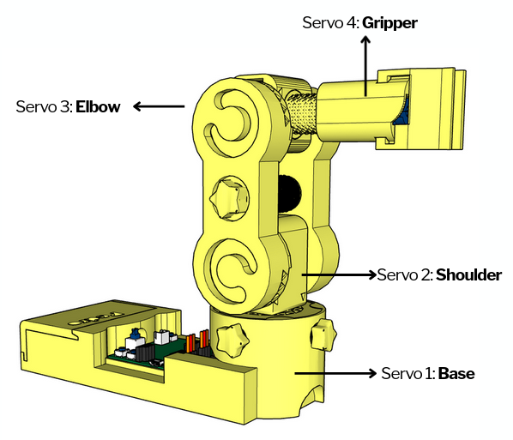**, each serving a distinct purpose in its movement. Three servomotors control the movement axes, while the fourth servomotor is dedicated to the gripper.**

* The **first servomotor** controls the base rotation, facilitating horizontal movement translation.
* The **second servomotor** manages the shoulder, enabling vertical rotation.
* The **third servomotor** operates the elbow, facilitating pick-up movements.
* Finally, the **fourth servomotor** controls the gripper, enabling Pedro to grasp objects securely.

Together, these servomotors enable Pedro to perform a wide range of precise and coordinated movements, making it an effective tool for various robotic applications.

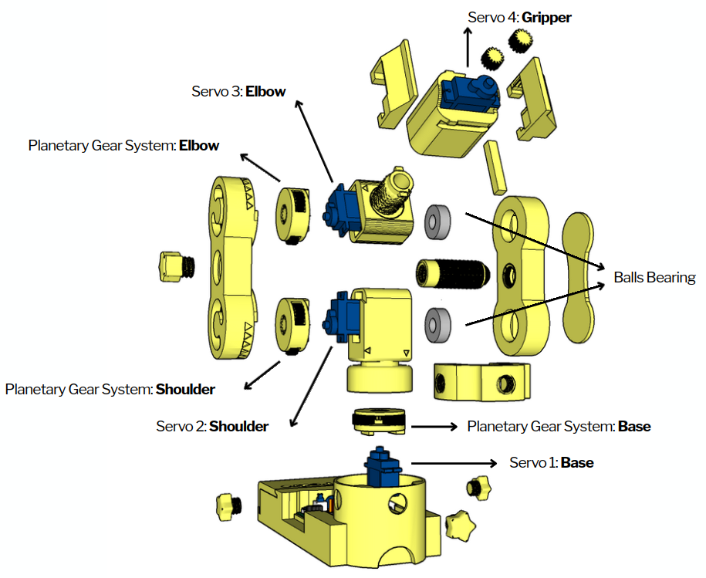

### ****3.2 Planetary Gear System****

Pedro features three planetary motion modules, fully 3D-printed. These modules enable smooth and precise movements, powered by a continuous servomotor motor placed at the center of each joint.

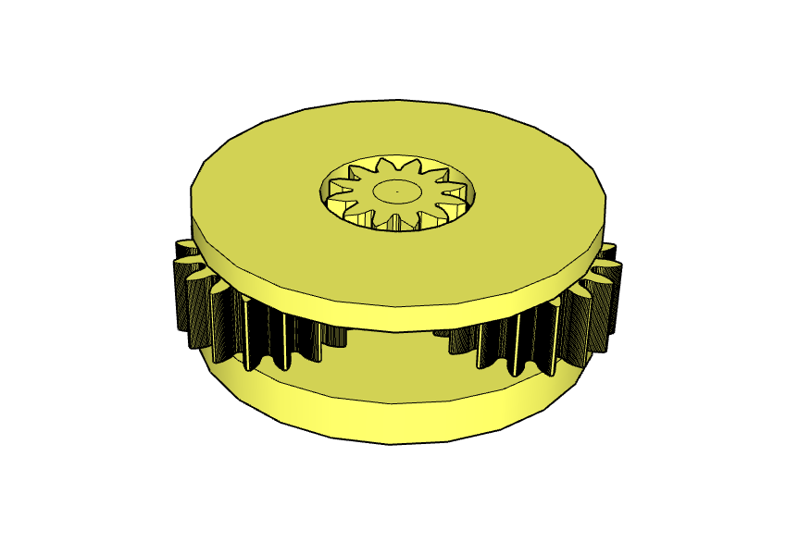

### ****3.3 What is a planetary gear system in robotics?****

A planetary gearbox is a gear mechanism that optimizes motion transmission by reducing speed and increasing torque. It consists of:  
⚙️ The sun gear: the central gear (driven by the motor)  
⚙️ The planet gears: three gears rotating around the sun  
⚙️ The ring gear (here replaced by Pedro’s structure), holding everything together

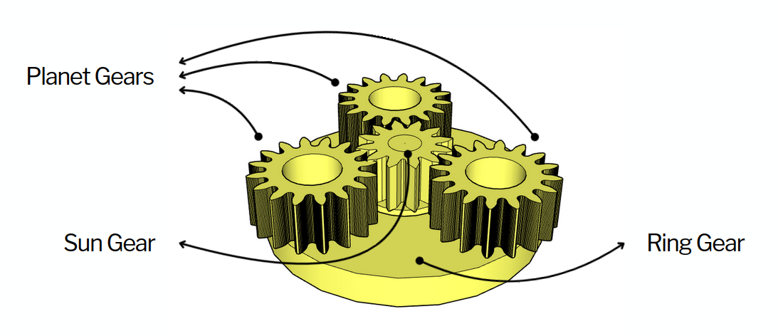

### ****3.4 Why use a planetary system on Pedro?****

✅ Increased power and precision  
✅ Compact and robust design  
✅ Fully 3D-printable with no complex parts

This system allows Pedro to execute smooth and precise movements in its three main joints: the base, shoulder, and elbow. No screws, no glue just 100% 3D printed.

## ****4. The Pedro Board****

**The **Pedro Board** is the brain of the robot. It is an **Arduino-compatible microcontroller board (ATmega32u4)** specially designed for the Pedro robot. It connects and controls all of Pedro’s parts from the motors to the sensors and communication modules.**

### ****4.1 Main Features****

* **Arduino Micro compatible** – easy to program with the Arduino IDE
* **4 servo motor outputs** – control the arm, base, and gripper
* **Integrated OLED screen (128×64)** – displays mode, messages, and feedback in real time
* **Wireless communication ports** for:
  + **nRF24L01** (radio control)
  + **HC-05** (Bluetooth connection)
  + **ESP8266-01** (WiFi / IoT mode)
* **Micro USB port** – for programming and USB Serial mode
* **Built-in battery charger** – for a 7.4V Li-ion or LiPo battery
* **Serial RX/TX pins** – for external module or debugging

### ****4.2 STEM Insight****

The Pedro Board introduces students to **embedded systems**, where hardware and software work together to make intelligent machines. It’s a perfect platform to **learn electronics, communication protocols, and real-world engineering design**.

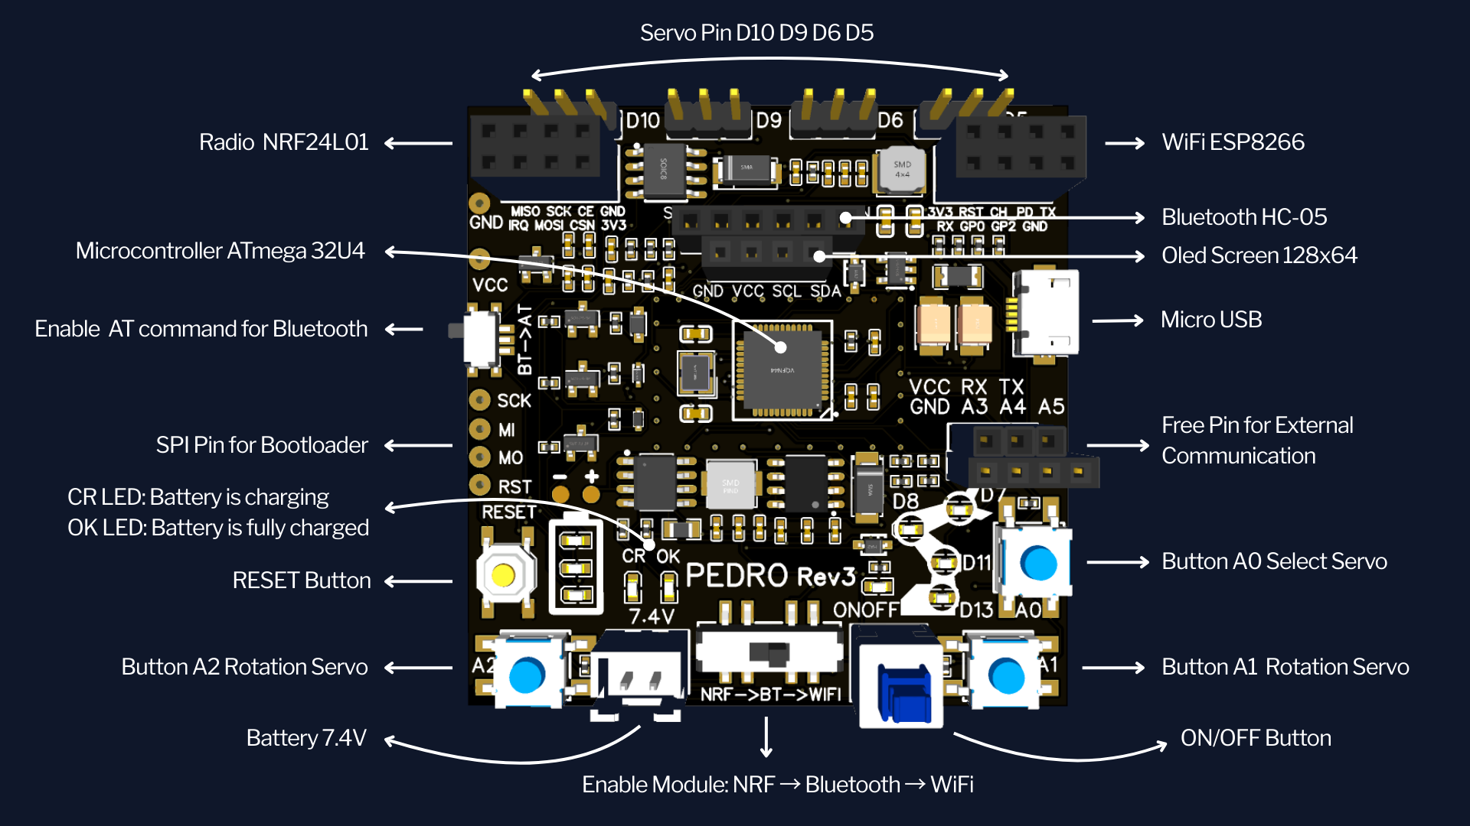

### ****4.3 Identify Each Element of the Pedro Board:****

Students can analyze and label:

* Programmable components (buttons, LEDs, servo pins)
* Power and battery indicators
* Communication module ports (Radio, Bluetooth, WiFi)
* USB and serial connections

This activity helps them recognize how each part contributes to robot operation.

**PART 1 : Identification of Non-Programmable Elements**

|  |  |  |  |
| --- | --- | --- | --- |
| Button ON/OFF | LED ON/OFF | LED CR**1** | LED OK**2** |
| 3x LEDs Battery**3** | Reset Button | Switch radio→bluetooth → wifi | Switch Command AT Bluetooth |

## 

1. **LED CR** : Indicates that the battery is currently **charging**.  
2. **LED OK** : Indicates that the battery is **fully charged**.  
3. **Battery Level LEDs:** Show the **battery charge level** from bottom to top (**25%, 50%, and 100%)**.

**PART 2 : Identification of Programmable1 Elements**

|  |  |  |  |
| --- | --- | --- | --- |
| LED Base D13 | LED Shoulder D11 | LED Elbow D8 | LED Gripper D7 |
| Pin Servo Base D5 | Pin Servo Shoulder D6 | Pin Servo Elbow D9 | Pin Servo Gripper D10 |
| Button A0 Select Servo | Button A1 Rotation Servo | Button A2 Rotation Servo | Microcontroller(the brain) |

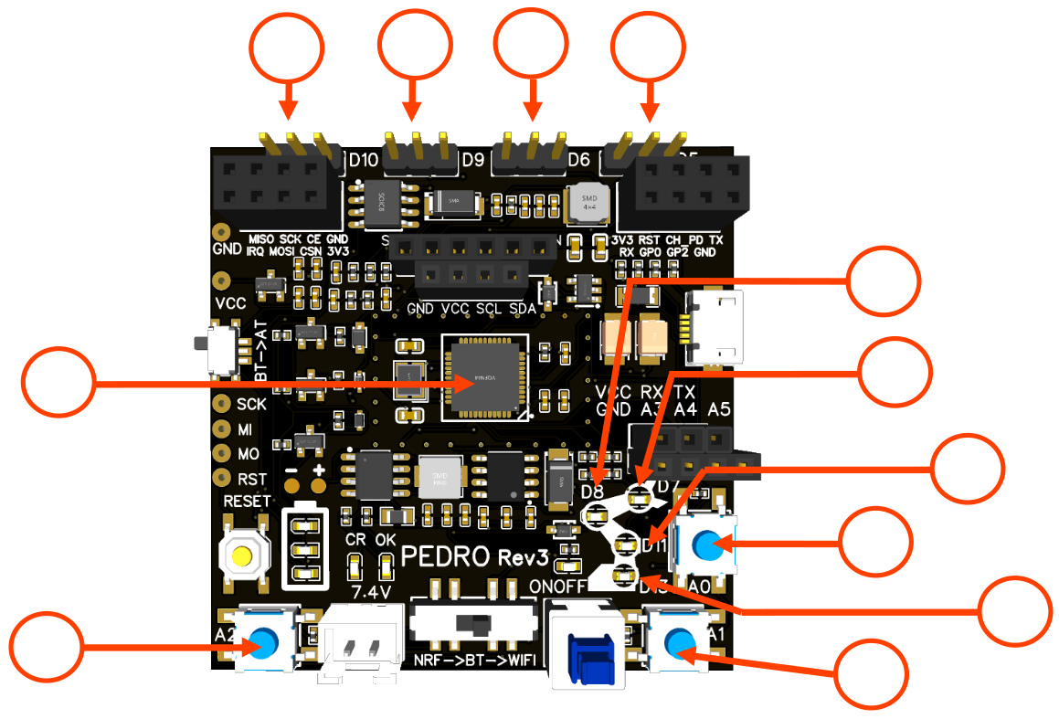

1. A **programmable element** is a component on the electronic board that can be **controlled by programming the microcontroller**. This can include **buttons**, **LEDs**, or **input/output pins**.

**PART 3 : Identification of Connectors**

|  |  |  |  |
| --- | --- | --- | --- |
| Module Radio | Module WiFi | Module Bluetooth | OLED Screen 128x64 |
| 7.4 V Battery Connector | Pin RX TX A4 A4 A51 | Port micro USB2 | Pin Bootloader3 |

## 

The pins **RX, TX, A3, A4, and A5** allow Pedro to **communicate with external devices**, such as an Arduino board, another Pedro robot, or components on a **breadboard** (e.g., a button or an LED).   
The **USB port** has **three main functions**:

1. **Programming** the board
2. **Charging** the battery
3. **Controlling** the Pedro robot via a **graphical interface**

## 5. Installing and Uploading Pedro Firmware

1. **Download and install** the latest version of the [Arduino IDE](https://www.arduino.cc/en/software).
2. **Install the required libraries** from the Library Manager:
   * **PedroRobot**: Tools → Manage Libraries → search **PedroRobot** → Install
   * **U8glib**: Tools → Manage Libraries → search **U8glib** → Install
   * **RF24**: Tools → Manage Libraries → search **RF24** → Install
3. **Insert the Oled Screen into the Pedro board and Connect** the board to your computer via USB.
4. **Select the correct port**:
   * Tools → Select the port that appear when you connect Pedro robot
5. **Select the board type**:
   * Tools → Board → Arduino Micro
6. **Open the example sketch**:
   * File → Examples → PedroRobot → Pedro
7. **Compile and upload** the sketch to your Pedro board.

✅ If everything is correct, Pedro’s OLED screen will display “MANUAL MODE”.

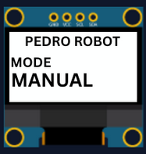

1. Press the button **A0** and observe what happen.  
   The LED corresponding to the selected servo light on. That button allows you to control each part of the robot. Here is the mapping between the LED ID and the servo ID

LED D13 → servo D5 (Base)  
LED D11 → servo D6 (Shoulder)  
LED D8 → servo D9 (Elbow)  
LED D7 → servo D10 (Gripper)

*Programming and embedded systems concepts will be covered in* ***Lesson 2****, where you’ll learn how the board operates and interacts with coding instructions.*

## ****6. Assembling****

💡 Pedro is entirely screw-free — all parts snap together easily!

### Step 1: The Base

Attach the first servo to the base structure. This servo controls the horizontal rotation.

|  |  |
| --- | --- |
|  |  |
|  |  |
|  |  |
|  |  |

### Step 2: The Gripper

Assemble the gripper with the fourth servo. Ensure it opens and closes smoothly.

|  |  |
| --- | --- |
|  |  |
|  |  |
|  |  |
|  |  |
|  | |

### **Step 3: The Arm**

Connect the shoulder and elbow servos. Check each movement before final assembly.

|  |  |
| --- | --- |
|  |  |
|  |  |

## ****7. Quiz (30 Questions)****

**1. What does the acronym P.E.D.R.O. stand for?  
A) Programmable Electric Device for Robotic Operation  
B) Programmable Educational Robot  
C) Printed Electronic Design Robotic Object  
D) Personal Educational Digital Robot  
✅ Answer:**

**2. What is the main goal of the Pedro Lesson 1?**  
A) Build a drone  
B) Discover the Pedro robot and understand its operation  
C) Learn 3D modeling only  
D) Program a mobile app  
✅ **Answer:**

**3. What type of microcontroller powers Pedro?**  
A) ATmega32U4  
B) ESP32  
C) Raspberry Pi  
D) STM32  
✅ **Answer:**

**4. What software is required to program Pedro?**  
A) Visual Studio  
B) Arduino IDE  
C) Python  
D) MATLAB  
✅ **Answer:**

**5. What kind of motor does Pedro use?**  
A) Stepper motors  
B) Brushed DC motors  
C) Continuous rotation servomotors (360°)  
D) Hydraulic actuators  
✅ **Answer:**

**6. How many servomotors are used in Pedro?**  
A) 2  
B) 3  
C) 4  
D) 5  
✅ **Answer:**

**7. What is the purpose of the first servomotor?**  
A) Controls the gripper  
B) Controls the base rotation for horizontal movement  
C) Controls the shoulder  
D) Controls the elbow  
✅ **Answer:**

**8. What does the fourth servomotor control?**  
A) The base  
B) The shoulder  
C) The elbow  
D) The gripper  
✅ **Answer:**

**9. What material is used to print Pedro’s parts?**  
A) Aluminum  
B) PLA or ABS plastic  
C) Steel  
D) Nylon  
✅ **Answer:**

**10. What makes Pedro unique in its construction?**  
A) It is 100% 3D printed with no screws  
B) It uses wooden parts  
C) It is laser-cut  
D) It is glued together  
✅ **Answer:**

**11. What tool is used to generate 3D printer instructions from a design file?**  
A) STL file  
B) G-code  
C) CAD model  
D) Firmware  
✅ **Answer:**

**12. What is the first step in 3D printing a part?**  
A) Generate G-code  
B) Export to STL  
C) Design in CAD  
D) Print immediately  
✅ **Answer:**

**13. What type of bearing system does Pedro use?**  
A) Magnetic bearings  
B) Ball bearings  
C) Roller bearings  
D) Gear bearings  
✅ **Answer:**

**14. What is the function of the base bearing?**  
A) Controls the gripper  
B) Stabilizes vertical motion  
C) Ensures stable and precise rotation  
D) Controls speed  
✅ **Answer:**

**15. What is the purpose of the planetary gear system in Pedro?**  
A) To reduce torque and increase speed  
B) To increase torque and improve precision  
C) To provide electrical power  
D) To connect sensors  
✅ **Answer:**

**16. How many planetary motion modules does Pedro have?**  
A) 1  
B) 2  
C) 3  
D) 4  
✅ **Answer:**

**17. Which gear in the planetary system is driven by the motor?**  
A) The planet gear  
B) The sun gear  
C) The ring gear  
D) The outer shell  
✅ **Answer:**

**18. What component allows Pedro to communicate wirelessly over long distances?**  
A) NRF24L01 module  
B) Wi-Fi router  
C) GPS module  
D) Ultrasonic sensor  
✅ **Answer:**

**19. Which module enables Pedro to connect to Wi-Fi ?**  
A) HC-05 Bluetooth module  
B) ESP8266-01 module  
C) NRF24L01 module  
D) GPS module  
✅ **Answer:** B

**20. What is the screen resolution of Pedro’s OLED display?**  
A) 64x64  
B) 128x32  
C) 128x64  
D) 256x128  
✅ **Answer:**

**21. Which component represents the “brain” of the Pedro board?**A) The OLED Display  
B) The ATmega32u4 Microcontroller  
C) The Battery Charger  
D) The NRF24L01 Radio Module  
✅ **Answer:**

**22. What type of display is integrated into the Pedro Board?**  
A) LCD 16x2  
B) OLED 128x64  
C) TFT 2.4"  
D) LED matrix  
✅ **Answer:**

**23. What function does the Micro USB port serve?**  
A) Power only  
B) Programming, charging, and serial control  
C) Bluetooth pairing  
D) WiFi connection  
✅ **Answer:**

**24. Which module provides WiFi capability?**  
A) NRF24L01  
B) HC-05  
C) ESP8266-01  
D) GPS module  
✅ **Answer:**

**25. What does the ATmega32u4 allow students to do?**  
A) Design 3D parts  
B) Program the robot using Arduino IDE  
C) Print STL files  
D) Connect motors directly  
✅ **Answer:**

**26. Which component shows the battery charge level?**  
A) LED CR  
B) LED OK  
C) Battery Level LEDs  
D) OLED screen  
✅ **Answer:**

**27. What does the LED “CR” indicate?**  
A) Bluetooth connected  
B) Battery charging  
C) Low voltage  
D) Power OFF  
✅ **Answer:**

**28. What switch is used to select between NRF, BT, and WiFi?**  
A) Power switch  
B) Communication switch  
C) Mode button  
D) Servo selector  
✅ **Answer:**

**29. What is the purpose of the RX/TX pins?**  
A) Power the LEDs  
B) Enable serial communication  
C) Control servos  
D) Connect battery  
✅ **Answer:**

**30. What kind of system is the Pedro Board a good example of?**  
A) Mechanical system  
B) Embedded system  
C) Hydraulic system  
D) Optical system  
✅ **Answer:**

**END  
Pedro STEM Lesson n°1**